# Supplementary Material S5 — SHAP-Based Explainability

Supplementary Figure S5. Individual-level SHAP interpretation

Panel S5A. SHAP force plots

Force plots illustrate individual prediction decompositions. Red elements denote features pushing risk upward, whereas blue elements indicate risk-lowering effects.

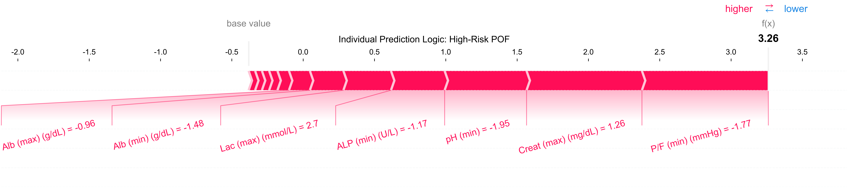

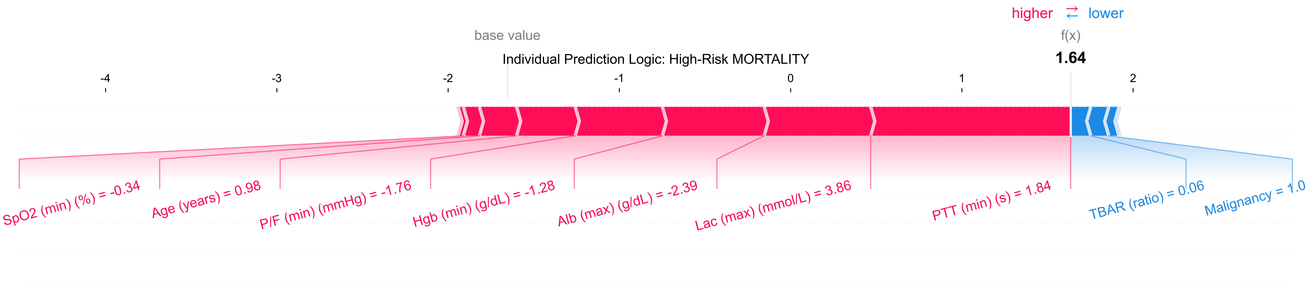

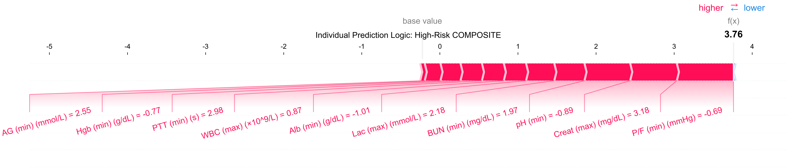

——————————

Panel S5B. SHAP dependence plots

Dependence plots show how changes in key predictors (e.g., creatinine, BUN, P/F ratio, pH, lactate, PTT) influence model output. These patterns highlight the central role of renal function, oxygenation, perfusion, and acid–base status in early deterioration.

